SOFT COMPUTING TECHNIQUES

(INT 246)

FUZZY LOGIC FOR MALARIA DIAGNOSIS G.U.I



Student Name: Joseph Acquah

Roll Number: 59

Section: KM107

Email Address : [vermashubham.srv@gmail.com](mailto:vermashubham.srv@gmail.com)

Faculty Member: Dr. Niharika Sharma

**TABLE OF CONTENTS**

INTRODUCTION

Malaria, a worldwide health threat, requires vital, especially accurate diagnosis and immediate suitable treatment. The main objective of this project is to design a fuzzy logic algorithm for malaria diagnosis. The GUI program for the malaria diagnosis was designed and simulated using the Jupyter Python Notebook provided by Anaconda Navigator with 12 Membership function and 2 fuzzy decision matrices were constructed and used.

Fuzzy logic is a very useful tool in dealing accurately with problems that appear to be solved only by human judgment when data is modeled well.

DESCRIPTION

The structure consists of four main components, namely GUI, fuzzification, inference engine and defuzzification. Two other components of the system are input data and output.

INPUT DATA

This component receives data into the system using input technology like keyboard. The user reads the exact number taken from the instruments for measuring the patients’ temperature, height, weight and pulse rate in Celsius(C), meters (m), kilograms (Kg) and BPM respectively. The converted intensity values are determined in 100% and entered.

FUZZIFICATION & DEFUZZIFICATION

In fuzzification, the crisp input values are converted to membership degrees, by applying the corresponding membership functions (fuzzifier). The aim of defuzzification is to generate a crisp value that will be representative of the output from the inference engine.

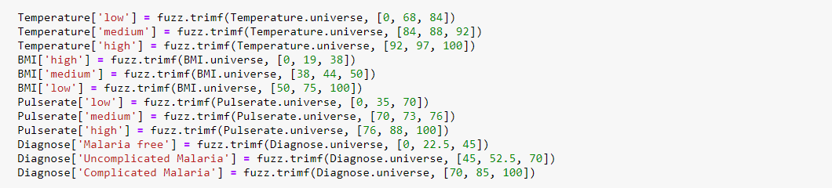

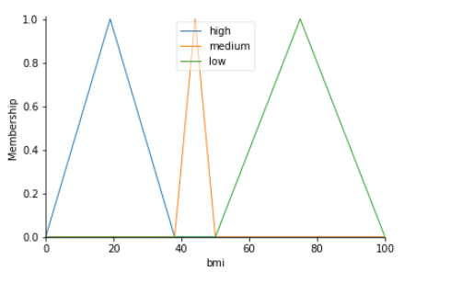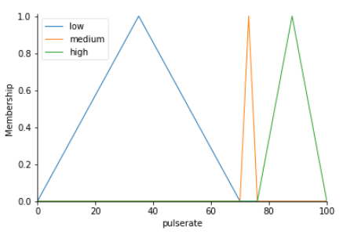

INFERENCE ENGINE

In the inference engine, fuzzified input is then matched with the rules and a set of fuzzy actions are generated. Sample of the rules are shown below:

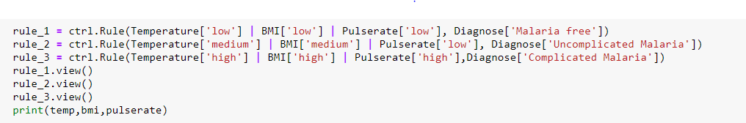

GUI - GRAPHICAL USER INTERFACE

The framework used in providing a user interface to the fuzzy logic system is the Tkinter framework that is built into the python standard library. Its cross-platform, so the same code works on Windows, macOS and Linux making visual elements to be rendered using the native operating system elements, so applications look like they belong on the platform where they’re run.

The layout was structured with widgets, where each frame was contained. The fuzzy logic algorithm was passed as “_skfuzzyfunction()” in the program and called whenever the “btn_convert” widget was called or clicked. Due to size and little experience of handling GUI programming the code use was simple without much complexity to produce efficient results and less constraints.

TEST CASE 1

A patient with

Temperature = 55 **°**

BMI = 20

Pulse Rate = 67

